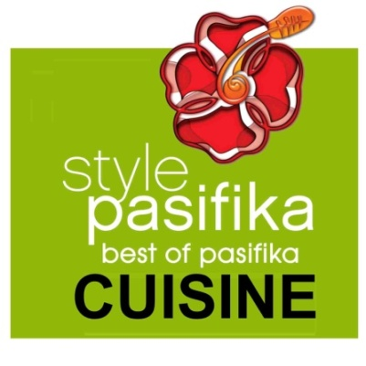

Media Release September 1, 2011

MEREDITH & BOSLEY BRING BEST OF PASIFIKA CUISINE
TO WORLD CUP VIPS AT STYLE PASIFIKA

Award-winning chefs Michael Meredith and Martin Bosley have teamed up to put Pasifika on a plate for 800 discerning guests, including Prime Minister John Key and VIPs visiting for Rugby World Cup, at this year’s Westfield Style Pasifika: Best of Pasifika fashion event.
As a highlight of the Real New Zealand Festival, which celebrates all things New Zealand during Rugby World Cup, this year Westfield Style Pasifika will run for two nights with one show for general public and one for VIPs and corporates, during Rugby World Cup 2011 finals week.
The event will showcase NZ’s identity as a Pacific Island nation and World Cup fever will be reflected in one-off rugby-inspired designs by top international designers from World Cup countries, as well as kiwiana inspirations from New Zealand’s top designers.
For the VIP show, Bosley and Meredith have been challenged with creating a sumptuous three-course dinner to encompass the theme of Style Pasifika: Best of Pasifika Cuisine.
Although the chefs have many fine-dining accolades to their names, they both admit to nerves about maintaining their high standards over 800 servings for diners at Style Pasifika, which is understandable with a guest list that including Rugby World Cup VIPs including some of the players and their wives as well as Prime Minister John Key with visiting international dignitaries.
Samoan-born Meredith, who is designing the entree, says it helps that he has been able to draw on his Pacific Island heritage to gain inspiration for the menu.
“I’ll be showcasing food from my Polynesian childhood,” says Meredith. “Our food has good, honest flavours which I’ve learnt to refine in my cooking.”
Bosley, who is creating the main course for the dinner, says both chefs have been guided by the philosophy that eating locally and in season delivers the best dining experience.
“The quality of our local produce alongside our place in the Pacific continues to inspire our cooking,” says Bosley. “We’re so fortunate that the clarity of flavours we seek for our cuisine are so pristine - and that we don’t have 2000 years of tradition prescribing how things should look and how they should taste. We’re able to bring influences from cultures around our Pacific into our cooking – and this subsequently becomes New Zealand cuisine.”
The two chefs have collaborated to create the dessert.
The three-course dinner will be matched with wines from Nelson-based Maori-owned Tohu Wines – a company that Style Pasifika’s creative director and producer Stan Wolfgramm says understands a dining experience embodies more than just a great wine.
“It’s also about a community, a nation, a heritage, a high performance standard, respect and mana - all things important to the success of Style Pasifika” says Wolfgramm.
“The Westfield Style Pasifika Fashion Awards are about celebrating the distinctiveness of Pasifika New Zealand, our uniqueness, our geographical and cultural point of difference to the rest of world – and that’s what guests at our corporate dinner will experience on their plates as the best of Pasifika cuisine; flavours and foods unique to this region,” he says.
Rounding out the Style Pasifika Cuisine dream team is hospitality industry icon and former Restaurant Association president Don Fletcher who will operate as a consultant to Style Pasifika to ensure delivery of the best possible culinary experience.
Wolfgramm promises this year’s Style Pasifika is an event not to be missed.
“If you’ve never seen a Style Pasifika show, this is the year to do it. With the inclusion of this special event dinner there’s the opportunity for New Zealanders and international guests to really experience a taste of Pasifika.
“Style Pasifika has its own unique flavour; it’s unpredictable, it’s contemporary. I know Martin and Michael’s culinary interpretation will deliver an equally outstanding result. I’m honoured to have them working as part of this year’s Style Pasifika Cuisine team.”

Westfield Style Pasifika
When: Tuesday 18 October (public event) & Wednesday 19 October 2011 (Hosting/VIP event)
Where: Vector Arena, Auckland
For more information visit www.stylepasifika.co.nz
ENDS
_____________________________________________________________________
For more information, images or to arrange interviews, please contact Kerri Jackson at Passion PR on 09 631 6690 or 022 088 5860

Westfield Style Pasifika 2011
Rugby meets the world of fashion, music, technology and dance in two incredible nights of distinctly New Zealand entertainment. Westfield Style Pasifika - Best of Pasifika New Zealand has been selected as a key event for the REAL New Zealand Festival, a nationwide celebration of all the things we love most about New Zealand. For two exclusive evenings in the week of Rugby World Cup Final 2011, musicians, dancers, cultural entertainers, artists and designers will come together to showcase the best of New Zealand and Pacific innovation and creativity. This will be an event that will not only strike a chord with Kiwis, but will catapult our unique Pasifika culture onto the world stage.

